

|  |  |  |  |  |  |  |  |  |
| --- | --- | --- | --- | --- | --- | --- | --- | --- |
|  | | | | | | | | |
|  | | ****INFORMATION GATHERING AND**** ****EXPLOITATION**** | | | | |  | |
|  |  | | | | | | |  |
|  | | | |  |  | | | |
|  | | | | Sheik Arshad |  | | | |
|  | | | | Date05-04-2022Course titleCS_TALAKUNCHI**PROJECT 3** |  | | | |
|  | | |  | | |  | | |



|  |  |  |  |  |  |  |  |  |
| --- | --- | --- | --- | --- | --- | --- | --- | --- |
|  |  | | |  |  | | |  |
|  | INSTRUCTIONS | | | | | | |  |
|  |  | | |  |  | | |  |
|  |  | |  | | |  | |  |
|  |  |  | **Project submission:**  Take screen shots of each and every task mentioned and make a report of each project in Word format only. | | |  |  |  |
|  | | | | |
|  |  |  |  |
|  |  |



|  |  |  |  |  |  |  |  |  |
| --- | --- | --- | --- | --- | --- | --- | --- | --- |
|  | |  |  | | |  |  | |
|  | | THE PROCESS | | | | |  | |
|  | |  |  | | |  |  | |
|  | TASK 1 Login to Metasploit and extract Ip address. | | | | | | |  |
|  | TASK 2 | | |  | TASK 3 | | |  |
|  | Do Nmap scanning on the IP, Extract Open port, and Version Details | | |  | Check the vulnerable version exploitation's procedure in rapid7 and start exploiting the following ports:  A)Telnet  B)FTP  C)SSH | | |  |

|  |  |  |  |  |  |  |
| --- | --- | --- | --- | --- | --- | --- |
|  | TASK: 1 | | | | |  |
|  | |  |  |  |  | |
|  |  | | | | |  |

* **Metasploitable Ip Address:**

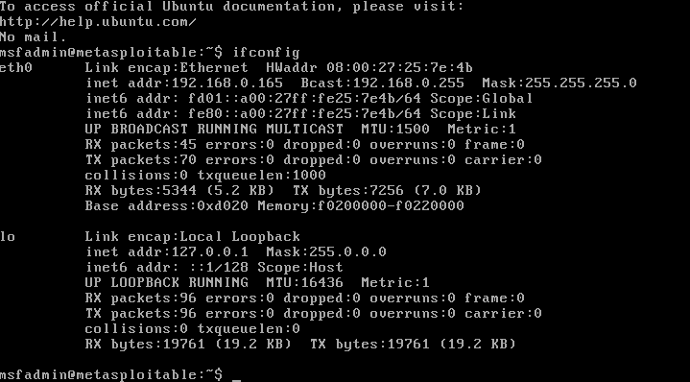

|  |  |  |  |  |  |  |
| --- | --- | --- | --- | --- | --- | --- |
|  | TASK: 2 | | | | |  |
|  | |  |  |  |  | |
|  | **Do Nmap scanning on the IP, Extract Open port, and Version Details** | | | | |  |

* **Nmap scanning on the Ip**

**cmd >> $**nmap -A target ip address

>>$nmap -A 192.168.0.165

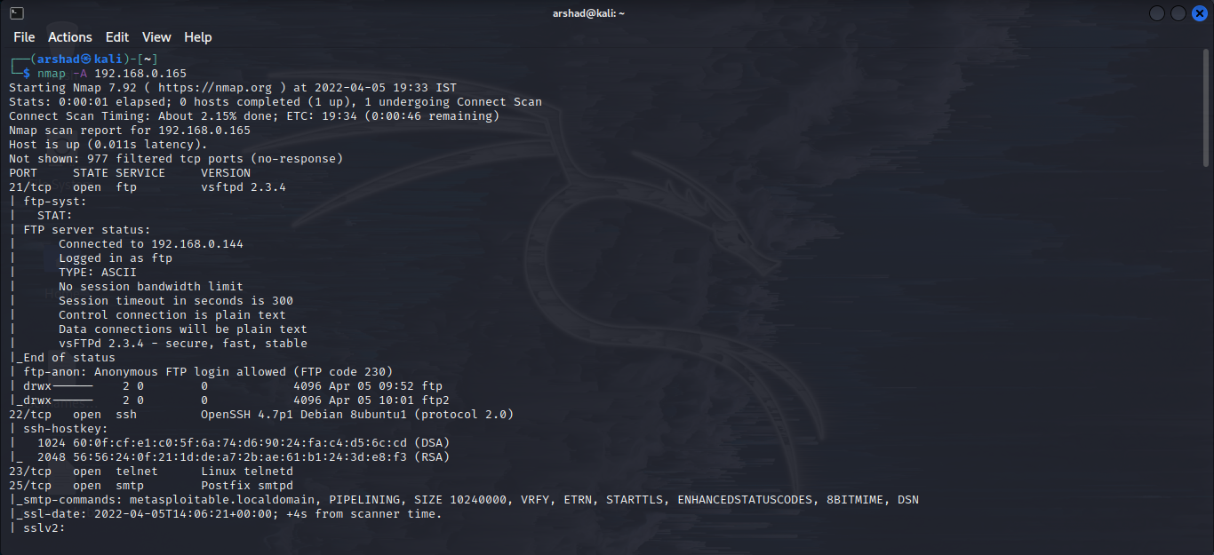

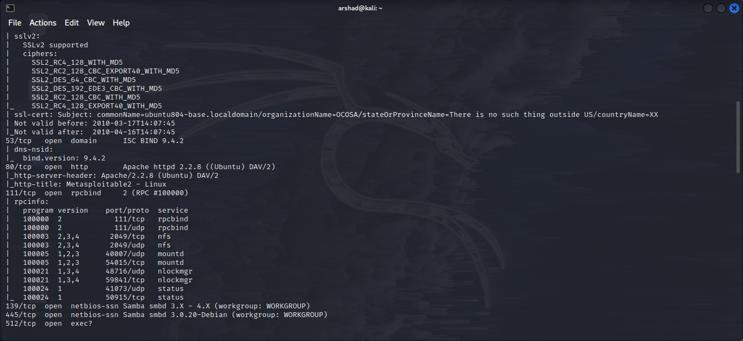

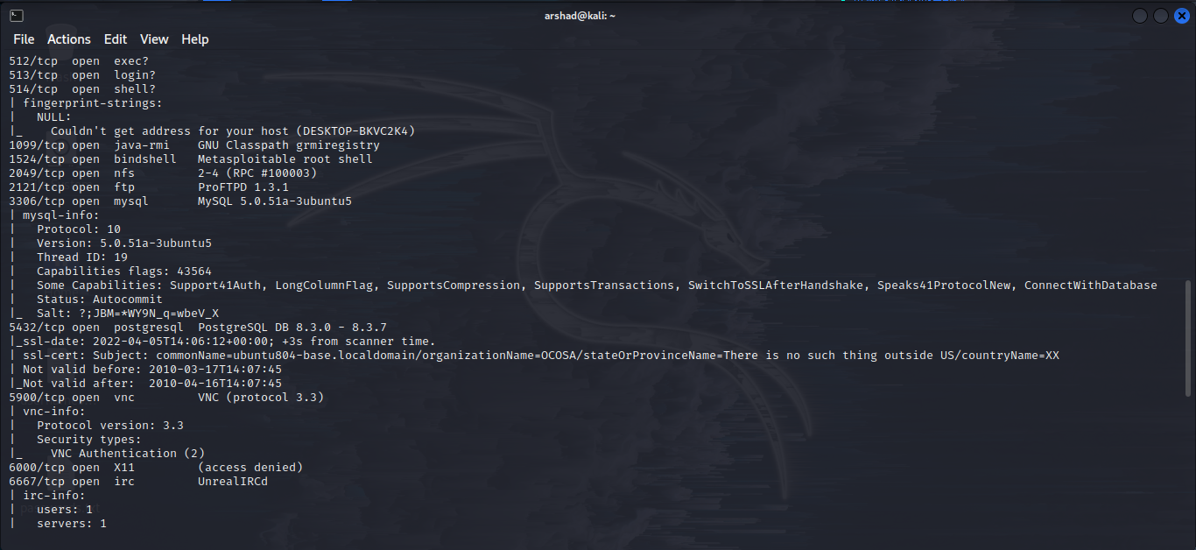

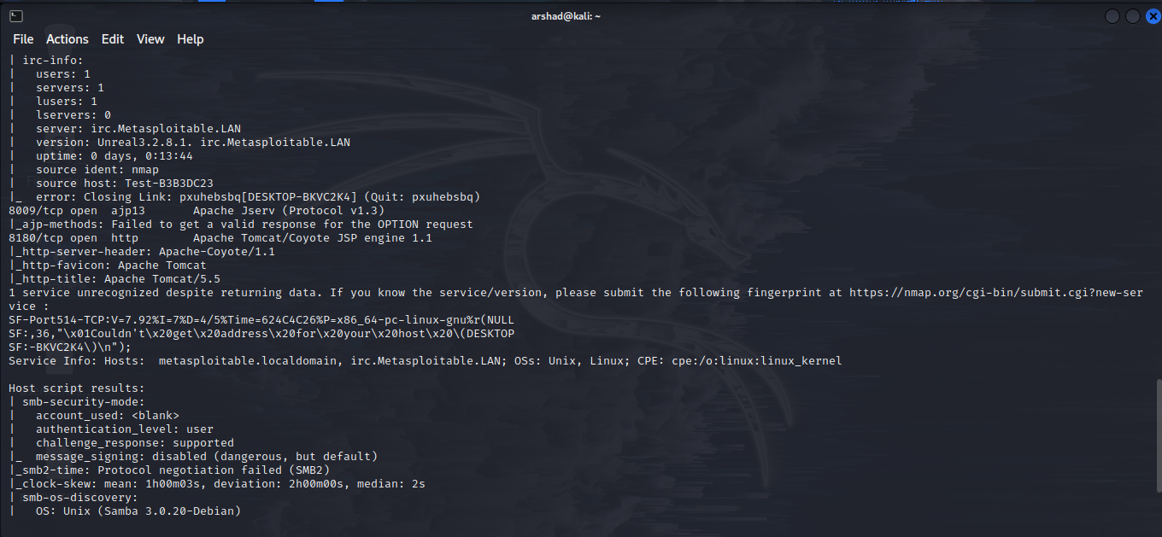

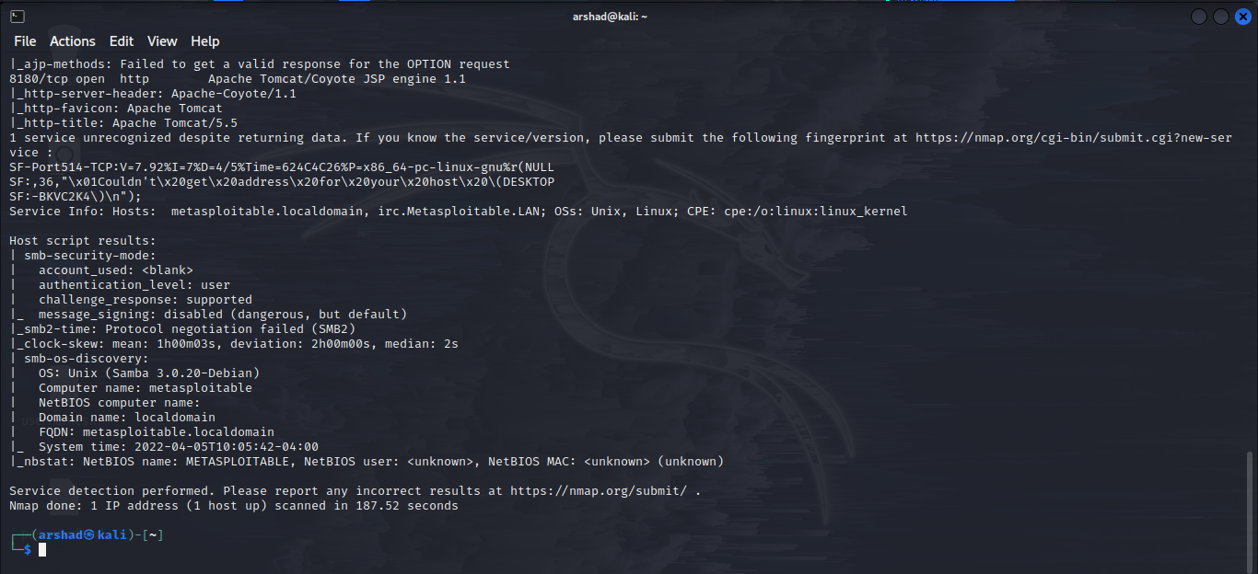

|  |  |  |  |  |  |  |
| --- | --- | --- | --- | --- | --- | --- |
|  | TASK: 3 | | | | |  |
|  | |  |  |  |  | |
|  |  | | | | |  |

**Check the vulnerable version exploitation's procedure in rapid7 and start exploiting the following ports:**

**A)Telnet**

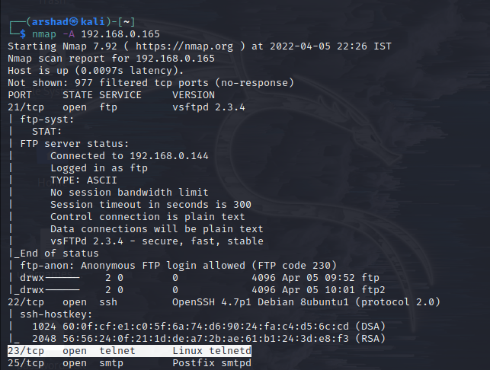

**telnet port exploit:**

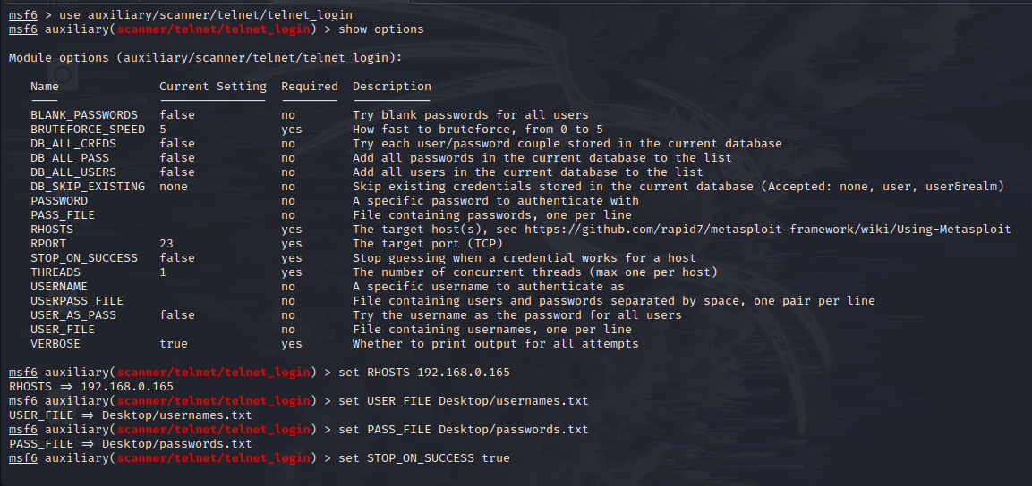

|  |  |
| --- | --- |
| **usernames.txt**  root  system  msfadmin  msconsole  user1  admin  meta | **passwords.txt**  12345678  root  system123456  msfadmin  admin  password  qwert4567 |

**exploit,**

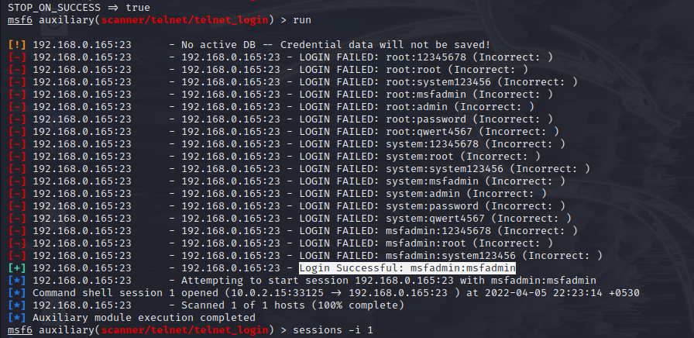

**Username**: msfadmin

**Password**: msfadmin

**Now, I have access to the Metasploit**

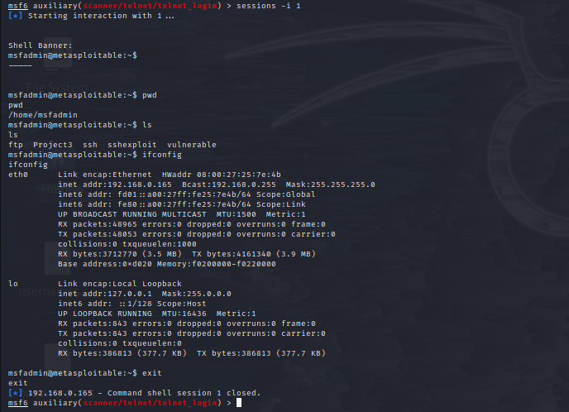

“ Successfully exploited TELNET Port ”

**B)FTP**

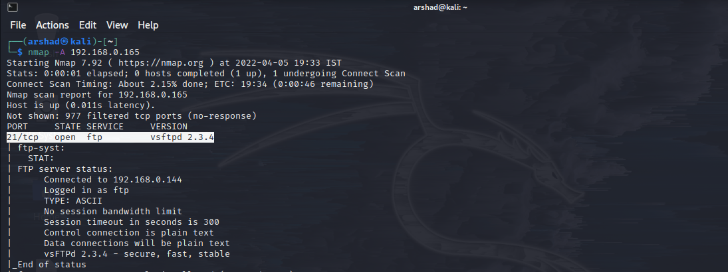

**ftp port exploit:**

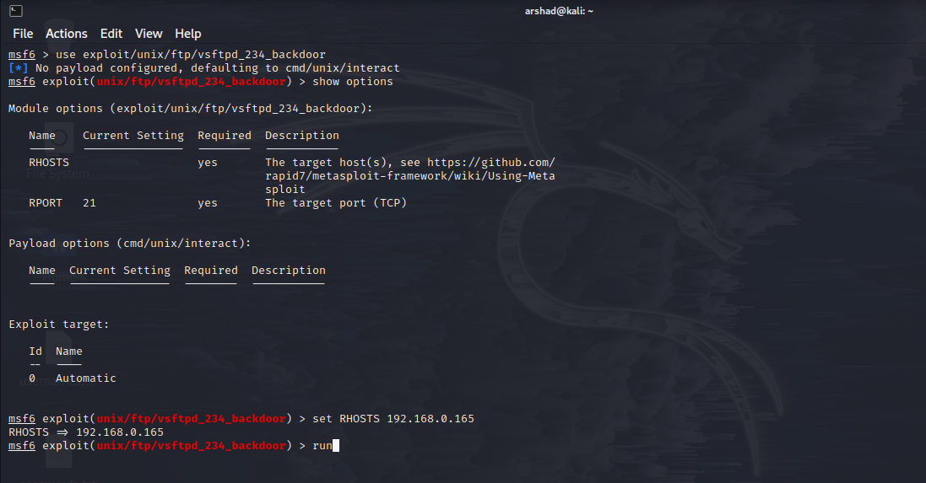

**Now, I have access to the Metasploit**

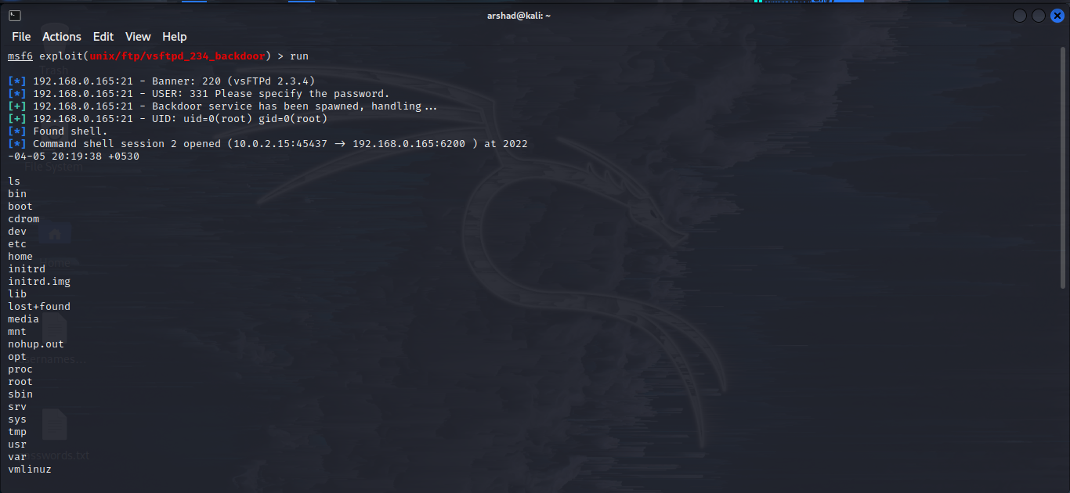

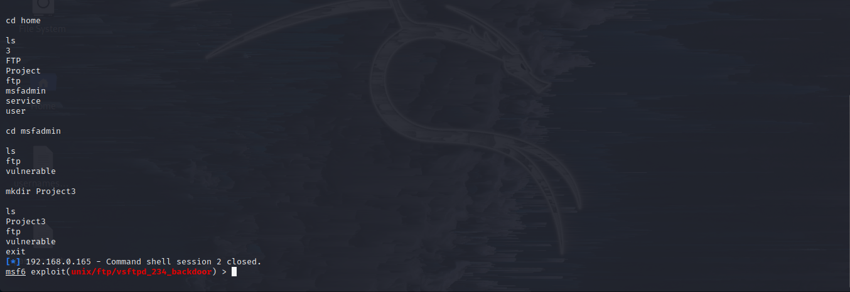

**Changes made in Metasploit**

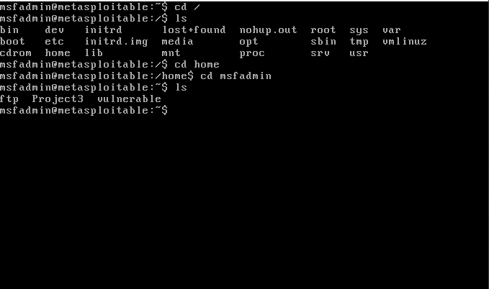

“ Successfully exploited FTP Port ”

**C)SSH**

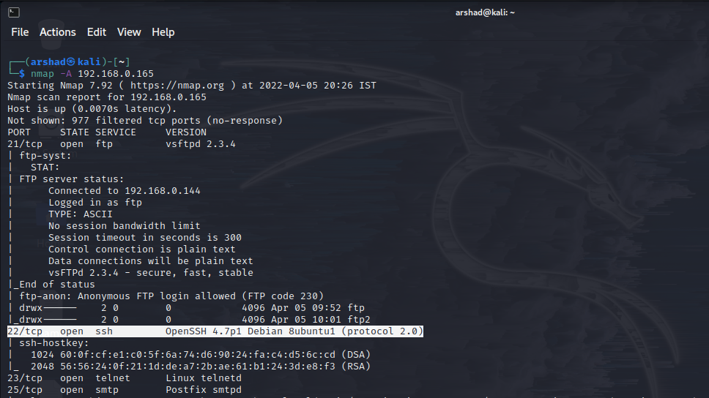

**ssh port exploit:**

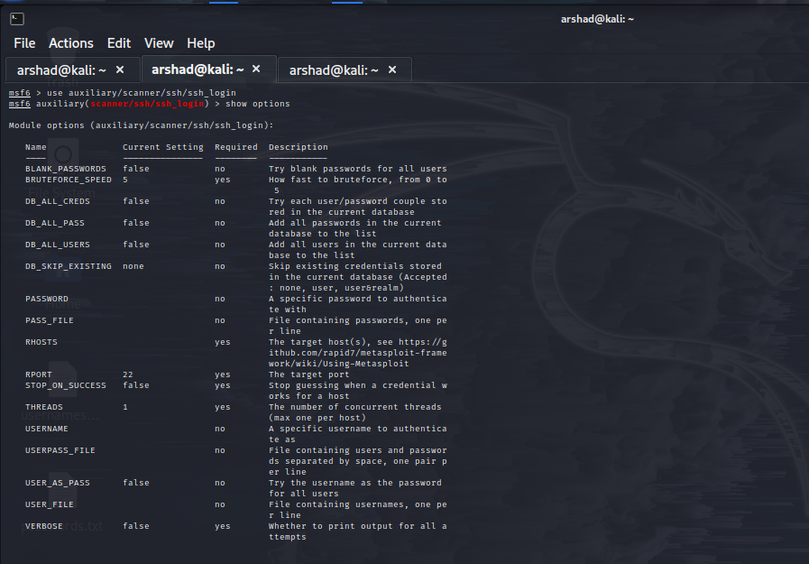

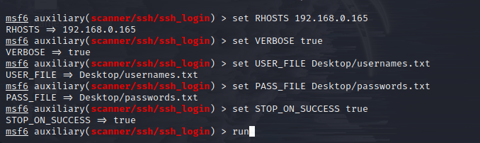

|  |  |
| --- | --- |
| **usernames.txt**  root  system  msfadmin  msconsole  user1  admin  meta | **passwords.txt**  12345678  root  system123456  msfadmin  admin  password  qwert4567 |

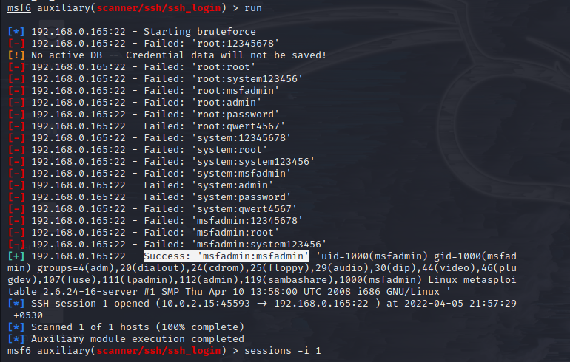

**Username**: msfadmin

**Password**: msfadmin

**Now, I have access to Metasploit**

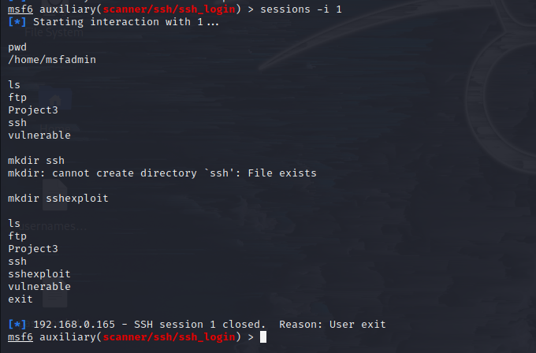

**>>**created a directory called sshexploit (through ssh session)

**Changes in Metasploit**

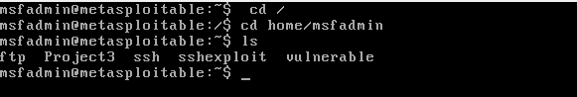

“ Successfully exploited SSH Port ”